COL341-Assignment2.2

Swaraj Gawande-2019CS10406

Part a

The trends for testing accuracy and training loss are given below.

Part B

Part c

At first with the same architecture and similar parameters I tried to perform gradient decent using different optimizers. Among which Adam performed the best Adadelta is not visible as it runs very similar to SGD.

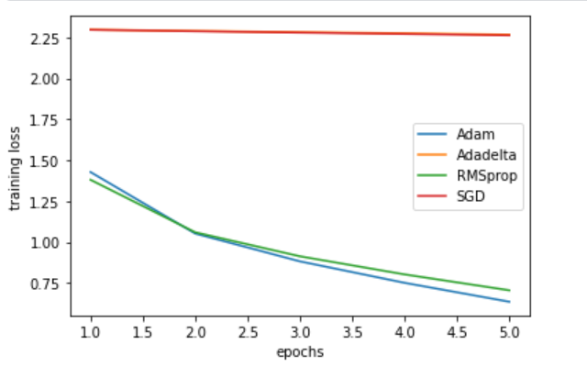

Then I tried setting up the learning rate for the gradient decent by varying it and learning rate =0.001 performed the best. Gradient decent with larger learning rate does not converge.

But it has some overfitting associated so I tried reducing the size of the convolutional layers which slightly improves accuracy but to keep it from overfitting I needed to go back to lr=0.0001.